**Gravity and Warped Space**

Names:

**Equipment**

Spacetime is a piece of fabric (such as a t-shirt) stretched through an embroidery hoop. Lift spacetime up from the table. It can be held or propped on books, etc. For the first set of observations, place the ruler across the embroidery hoop.

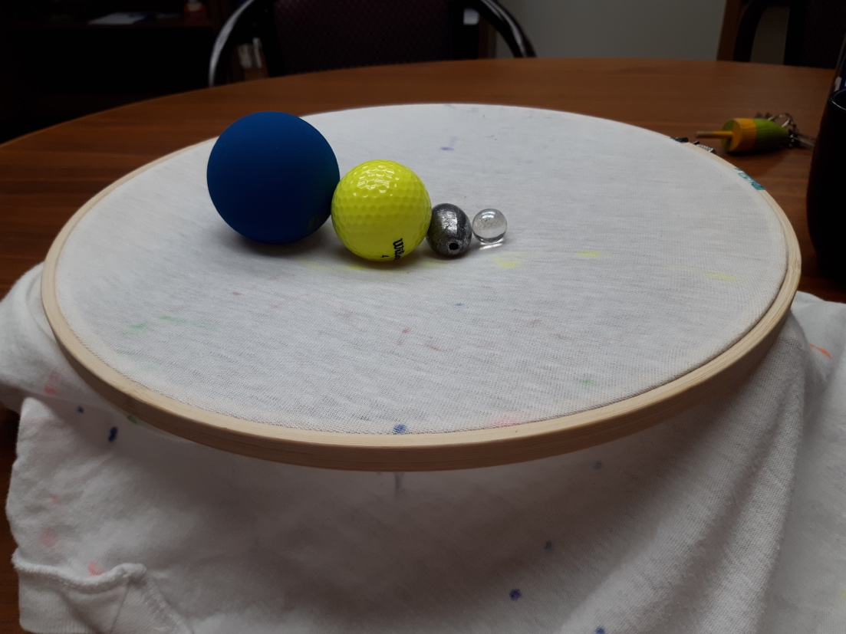

You should have four balls. Rank the balls from heaviest to lightest.

Racquet ball

Golf ball

Marble

Fishing sinker

**Mass**

1. Place the fishing sinker in the center of spacetime. This represents a massive star. Remove the sinker and place the racquet ball in the center of spacetime. This represents a planet, like Jupiter. Remove the racquet ball, and place the marble in the center. The marble represents a planet like Earth.
   1. What differences do you observe between Earth, Jupiter, and the star’s effect on spacetime?

*The heavier objects warp spacetime more.*

* 1. Does every object cause spacetime to deform?

*Yes.*

*[Principle: general relativity. Mass deforms spacetime. Heavier objects have more mass and more gravity.]*

1. Place the star (sinker) in the center of spacetime. Now, place the planet (marble) towards the edge.
   1. What happens?

*The marble rolls towards the sinker.*

* 1. Repeat this observation with the golf ball (a medium mass star). Which star has a stronger effect on the planet?

*The sinker affects the planet more.*

* 1. How do you know?

*The planet rolls in faster for the more massive star.*

*[Principle: gravitational acceleration is larger for more massive objects.]*

1. Place the sinker in the center of spacetime. Place the marble and golf ball at the edge.
   1. Which planet will reach the star first?
   2. Why do you think so?
   3. Now let them roll in. What happened?

*They reached the sinker at the same time. The balls roll in at the same rate.*

*[Principle: Gravitational acceleration is independent of the planet’s mass]*

1. Place the golf ball in the center of spacetime.
   1. Do you think you can place the marble in a location where it will not fall in towards the star? If so, where?
   2. Try placing the marble at different locations. Are you able to find a location where it will not fall towards the center? How many centimeters away?

*Yes*

* 1. Repeat the experiment with the racquet ball instead of the marble. What happens?

*Racquet ball falls in towards the star*

* 1. Now move the racquet ball and golf ball around until they are both stationary. How many centimeters away are they?

*Further than the measurement made in part b.*

*[Principle: Larger objects feel a stronger gravitational force]*

1. Turn your observations into a theory of physical principles. General relativity says that gravity is nothing more than the warping of spacetime.
   1. Based on your observations of how objects warp spacetime, what kind of objects have the most gravity? What physical property of the object determines the amount of gravity it has?

*Stars have more gravity. Heavy objects have more gravity. The amount of gravity an object has depends on how heavy or massive it is.*

* 1. The force of gravity depends on three things. One is the mass of the central star, as you determined in part a. What are the other two? (hint: consider what happened in part 4b as you moved the marble near and far. And then consider what happened when you replaced the marble with a heavier object).

*The distance of the planet from the star and the mass of the planet.*

**Orbits:**

1. We are going to get planets into orbit. Put the golf ball in the center of spacetime. Use the planet marble, and try to get it to move in a circle around the central star. What observations can you make about this process?

*It either falls over the edge or has an elliptical orbit. It always spirals into the star. It doesn’t move in a circle.*

*[Principles: planets move in elliptical orbits. Obtaining a circular orbit takes just the right velocity. Drag will decrease an orbit.]*

1. Now, switch places. Put the marble in the center of spacetime. Try to get the golf ball to orbit around the star. What happens?

*Won’t work! Heavy ball deforms spacetime more, so smaller ball always falls towards it.*

*[Principle: less massive things orbit more massive things, not the other way around.]*

1. Turn your observations into a theory of physical principles. Because of friction, the planet sometimes spiraled into the central star. Without friction, the planet would stay in its initial orbital path.
   1. What shapes of orbits can a planet have? Does it have to stay in orbit around a star, or can it wander off? What property of the planet’s motion determines its orbit?

*Many shapes, like ellipses. Planets can also fly off, if they are moving fast enough. Velocity determines a planet’s orbit.*

* 1. Why do planets orbit stars, instead of stars orbiting planets?

*Stars have more gravity, so a stronger force pulling the planet towards it.*